
Second International John Thelwall Conference
University of Derby
21-23 July 2017

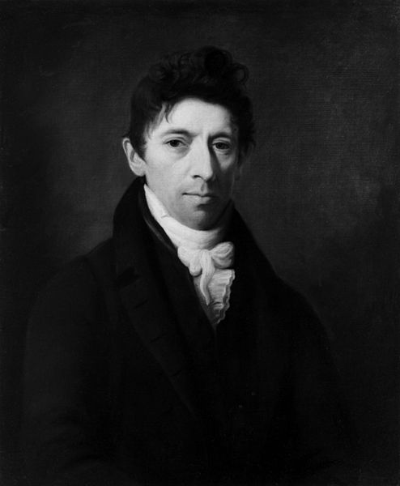

Co-organisers:
Dr. Paul Whickman, University of Derby
Professor Paul A. Elliott, University of Derby
Professor Judith Thompson, Dalhousie University
Kathryn Hindmarch, University of Derby
Val Derbyshire,University of Sheffield



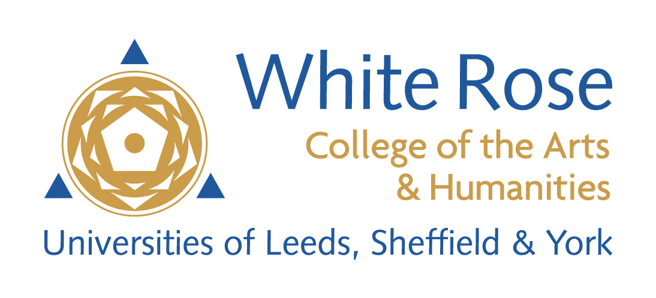

With Thanks

The planning committee would like to thank the Local Studies Library of Derby for their invaluable assistance in facilitating research towards this conference, hosting delegates at a special viewing of their holdings and with the organisation process.

We are grateful to BARS for contributing funding to the conference.

We are grateful to AHRC/White College of the Arts & Humanities for their generous funding which enabled the historical re-enactment/radical pub night to take place.

Conference Schedule Overview



All the conference panels will take place at 1 Friargate Square, which is part of the University of Derby campus and home to the Derby Law School. Located in the city centre, this building offers modern, well-equipped meeting and seminar rooms and IT facilities.

Friday, 21st July 2017

13.00 Registration, coffee and cakes (please note, lunch is not provided on Friday)
13.30 Welcome and Opening Remarks
13.45 Panel 1: “Origins”
15.30 Tea, coffee and petit fours
16.00 Panel 2: “Nature and Art”
17.30 End of Panel Two
19.30 Radical Pub Night

Saturday, 22nd July 2017

09.00 Morning coffee
09.30 Key note address
11.00 Coffee break
11.30 Panel 3: “The Legal Trials”
12.30 Lunch
13.30 Conference Excursion: Visit to the Local Studies Library, Derby, to view the Thelwall Holdings.
16.00 Afternoon tea and coffee at 1 Friargate University buildings.
16.30 Panel 4: “Erasmus Darwin”
18.00 Wine reception
20.00 Conference dinner, Le Bistrot Pierre, Friargate

Sunday, 23rd July 2017

09.30 Morning coffee
10.00 Panel 5: “Local Networks”
11.30 Coffee break
12.00 Panel 6: “Radical Urban Landscapes”
13.30 Lunch
14.15 Panel 7: “Global Implications”
15.30 Closing remarks by the conference organisers.

Friday, 21st July 2017

13.00 Registration, coffee and cakes (please note, lunch is not provided on Friday)

13.30 Welcome and Opening Remarks
Professor Kathryn Mitchell, Vice-Chancellor, University of Derby

13.45 Panel 1: “The Derby Manuscript: Origins, Nature, and Significance”
Chaired by Professor Judith Thompson, Dalhousie University

“The Derby Manuscript: Provenance, Relevance, Access”
Mark Young, Librarian, Derby Local Studies Library

“John Thelwall’s Metaphysical Lancet: Materialism in the Derby Manuscript”
Yasmin Solomonescu, University of Notre Dame

“Thelwall, Wordsworth and the Prosody Wars”
Richard Gravil, Independent Scholar

“Survival and Revival: The Networks of the Derby Manuscript”
Judith Thompson, Dalhousie University

15.30 Tea, coffee and petit fours

16.00 Panel 2: “Nature and Art”
Chaired by Professor Judith Thompson, Dalhousie University

“’Such is the Moral Beauty of Truth’: Visible Virtue in the Works of John Thelwall and Charlotte Smith (1749-1806)”, Val Derbyshire, School of English, University of Sheffield

“Surface and Depth: Reassessing Joseph Wright’s Portrait of an Unconventional Woman of Substance”, Peter Collinge, University of Keele

James Hogg’s Confessions of a Justified Sinner as a radical representation of evil” by Catherine Harrison.

17.30 End of Panel Two.

19.30 Radical Pub Night to be held at The Old Bell Pub, Friargate, Derby

An historical re-enactment featuring the political poetry of John Thelwall and his contemporaries, the performance of scenes of historical controversy from Derby’s eighteenth-century past, scripted from original sources held in the Derby local archives and performed live by actors from students of the University of Derby, Sheffield Hallam University and University of Sheffield’s theatre programme. Plus, contemporary poetry of protest.

Saturday, 22nd July 2017

09.00 Morning coffee

09.30 Key note address: “Thelwall’s Networks” by Professor Jon Mee, University of York

11.00 Coffee break

11.30 Panel 3: “The Legal Trials”
Chaired by Val Derbyshire, School of English, University of Sheffield

“’[L]et these volumes be my witness’: the trials of John Thelwall, 1794-1801”, Fiona Milne, University of York

“John Thelwall and Thomas Erskine”, David Watkinson, Barrister

12.30 Lunch

13.30 Conference Excursion: Visit to the Local Studies Library, Derby, to view the Thelwall Holdings.

Led by Mark Young, Librarian, Derby Local Studies Library

Delegates are requested to set out from 1 Friargate at approximately 13.20, and will be guided by the Conference Organisers to the Local Studies Library building.

16.00 Afternoon tea and coffee at 1 Friargate University buildings.

16.30 Panel 4: “Erasmus Darwin”

With Professor Jonathan Powers, Quandary Books and
Dr. Paul A. Elliott, University of Derby. Details to be confirmed.

18.00 Wine Reception

20.00 Optional Conference Dinner at Le Bistrot Pierre, 18 Friargate, Derby

Sunday, 23rd July 2017

09.30 Morning coffee

10.00 Panel 5: “Local Networks”
Chaired by Professor. Paul A. Elliott, University of Derby

“The Pentrich Rebellion: A Nottingham Affair?”, Richard Gaunt, University of Nottingham

“Artisanal Radicalism in the East Midlands: John Blackner’sBattle of Marengo”, Sam Ward, Nottingham Trent University

“Thelwall and the Birmingham Radicals”, Nicholas Benbow, Independent Researcher

11.30 Coffee break.

12.00 Panel 6: “Radical Urban Landscapes”
Chaired by Dr. Paul Whickman, University of Derby

“With Henry Hunt we’ll go my boys”: The Creation of Henry Hunt, the Radical Celebrity”, Caitlin Kitchener, University of York

“John Thelwall’s Radical Urbanism”, Kate Scarth, Dalhousie University

“Scientific Materialism and Education: the Radical Project of Thelwall’s Panoramic Miscellany”, Jane Boyes, Dalhousie University

13.30 Lunch

14.15 Panel 7: “Global Implications”
Chaired by Kate Scarth, Dalhousie University

This closing panel is dedicated to the memory of Professor Bill Speck (1938-2017), the distinguished historian of eighteenth-century Britain and America, formerly at the University of Leeds and University of Nottingham.

“Transatlantic Paine in the Early Nineteenth Century – Jacobin or Loyalist Cult?”, Matthew Roberts, Sheffield Hallam University

“Affiance on affiance multiply’: John Thelwall and the Hope of Future Time”, Judith Thompson, Dalhousie University

15.15 Closing remarks by the conference organisers.

15.30 Close

Obituary of W. A. Speck

[Written by Lawrence Goldman for the Institute of Historical Research]

The IHR records with great sadness the recent death of Professor W. A. ('Bill') Speck whose work on seventeenth and eighteenth century British History will be known to many. Below we publish a personal appreciation by Tony Claydon, Professor of Early Modern History at Bangor University.

Anyone who has been interested in the late Stuart, or Georgian, periods of British history, will have been saddened to learn of the death of W.A. (Bill) Speck in February 2017. Bill was a political historian of great erudition, rigour, scholarship, and reliability. To those who did not know him or his work, this may suggest he was a little stodgy. But nothing could be further from the truth.

First, and perhaps foremost (for academics value the personal too little), there was his huge charm. This not only made attending any seminar or conference in which he was involved a great pleasure, but had a hugely positive impact on the future of the profession. This was because Bill so often deployed his charm to encourage and enthuse young researchers. This current writer was certainly not the only graduate student to have been bowled over by his interest and engagement when I nervously outlined my first research project to one of the most respected scholars of my field.

Bill also raised the profile of his chosen period, through his great clarity of exposition. This made him a master of survey texts that laid the groundwork for many people’s understanding of Britain in the seventeenth and eighteenth centuries. Underlying both these services to history, was a passionate interest in the past,that led him into enquiries that pioneered whole new subjects of research. Frequently the waves of scholarly fashion broke on shores that Bill had already discovered and explored, following the logic of his sources and questions. For the late Stuart period alone, his work on the division between whigs and tories led him to a deep conception of the social dimension of politics, that more than prefigured the wider shift in interest from elite manoeuvrings to a wider political culture.

His work on the press and the electorate described a vigorous and participatory ‘public sphere’, well before that term became a crucial and ubiquitous tool of analysis. His work on Queen Mary II – invaluable to my own writings, as a biographer of William III – opened questions of monarchical influence, court culture, and the gendered structuring of power: but as always with Bill, these stimulating enquiries arose from his basic curiosity about how Britain worked rather than being led by modish theory.
Other commentators are better placed to reflect on his impact on study of the Georgian decades. Yet for the late Stuart era, Bill was key to rescuing it from an overshadowing by the pre-civil-war era; and its recognition as a potential crucible in which the modern world was formed. For this, though perhaps even more for that sparkling conviviality, he will be remembered with great respect and affection.

