

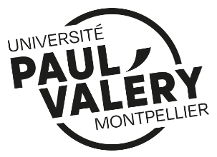
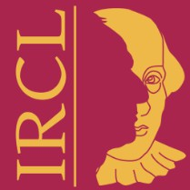
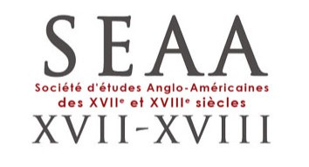




We invite proposals for papers for this year’s collaborative Postgraduate and Early Career Researcher Conference between the British Society for Eighteenth-Century Studies, the Société d’Études Anglo-Américaines des XVIIe et XVIIIe siècles and the Société Française d’Études du XVIIIe siècle, held at the University of Montpellier Paul-Valéry.
CALL FOR PAPERS: “Improvement, Degeneration, Stagnation”
3-4 September 2026, University of Montpellier Paul-Valéry
On 17 August 2020, the Faculté de Médecine de Montpellier celebrated the 800th anniversary of its foundation, making it the oldest medical university in the world still in operation.
Throughout its long history, the Faculté de Médecine fostered vast international connections and promoted a large number of innovations in the fields of anatomy, botanics, surgery and pharmacy, some of which are reflected in the very architecture of the city: the Jardin des Plantes, for instance, was France’s first university botanical garden. Created in 1593, it is still a highlight of the city today.
Inspired by Montpellier’s role in the advancement of medical knowledge in Europe, this year’s conference will centre on the notions of improvement, degeneration and stagnation or, in French, progrès, dégénérescence et stagnation.
French eighteenth-century scientist Antoine-Laurent de Lavoisier held the reasoning that matter is neither destroyed nor created during a chemical reaction, but that it instead undergoes change. He naturally sought to make it into a law of modern science, and the coinage “Rien ne se perd, rien ne se crée, tout se transforme” helps shed light on the complex and multiple aspects of this three-worded conference theme that may appear to describe one unique process as well as three distinct ones.
Referring to a process of gradual betterment, the notion of improvement became a key feature of English discourse during the seventeenth and eighteenth century. While improvement is close to the French progrès (progress) or amélioration (amelioration), there is no equivalent translation. We ask delegates to consider - is the concept of improvement inherently British? What shape does the drive towards material, moral and intellectual improvement take in various early modern contexts and places? Do degeneration and stagnation carry similar distinctions for different countries and communities?
Concepts of improvement also had a darker side. Aligned with Enlightenment thought, European colonial powers in the eighteenth century aimed to ‘improve’ and ‘civilise’ many of the people around the world whom they claimed dominion over, leading to the loss of native communities and cultures. In the context of British Caribbean slavery, claims of ‘amelioration’ (legislated through the Amelioration Act of 1798) were a means for supporters of the slave trade to delay abolition. Such views call into question the aims of ‘improvement’, or progrès, and highlight their potential racist and colonial connotations.
We invite delegates to interpret the terms improvement, degeneration and stagnation widely, with no geographical, etymological and conceptual bounds. Topics considering improvement, degeneration and stagnation could include, but are not limited to:
- The materiality of any of, or all, these terms
- Social, economic, moral and physical wellbeing
- Medical perspectives, including the development of psychiatric and psychological medicine and alternate (pseudo-)scientific endeavours such as alchemy or spiritualism
- Ideas around taste, attitudes, values and class, both in the social and literary domains
- Debates and evolutions regarding language
- National identities and comparisons, as well as the place of notions of improvement, stagnation and degeneration in national rivalries
- The pace of improvement and/or degeneration
- Science, innovation and the improvement of knowledge
- Colonisation and slavery
- Religion, secularisation and Enlightenment thought
- Gender, sexuality and the perception of the female body
- Conceptions of improvement or degeneration in art, design and architecture; as well as in literature and philosophy
- The notion of change and teleological narratives of progress
- The ambiguities surrounding the notion of progress and the uncertain boundaries between improvement, stagnation and degeneration
All submissions should be sent to montpellierconference2026@gmail.com for consideration. Submissions can be in either French or English. For individual papers, please send abstracts of 250 words and a short biography. For fully formed panels, (3-4 speakers), roundtables or workshops please send abstracts of 250 words for each paper along with brief details of the proposed theme, biographies of speakers, and proposed chair. CFP opens 7th January 2026 and closes 13th March 2026.

